**CS 385 PROJECT**

**Commercial Parking System and Number Plate Detection**

**Introduction:**

Urban areas are grappling with the escalating challenges of inefficient space utilization and parking congestion. The existing parking systems often lack intelligence, resulting in frustration for drivers, increased traffic congestion, and a negative impact on overall urban mobility. In recent times, License plate recognition has garnered significant interest due to its potential to revolutionize a wide range of applications, including law enforcement, traffic management, toll collection, and parking management. By automating the process of identifying and extracting alphanumeric characters from license plates in images or videos, ANPR systems offer numerous benefits, such as enhanced security, improved traffic flow, and streamlined operations.

**Solution Approach:**

The solution approach involved the utilization of computer vision methodologies for slot detection and monitoring in a parking scenario. Initially, camera calibration was executed to rectify image distortions, obtaining critical parameters such as the camera matrix and distortion coefficients. Subsequently, ArUco markers were integrated for marker-based detection, with a comprehensive dictionary facilitating real-time marker identification. This formed the basis for a robust slot monitoring system, recording slot occupancy and entry/exit times based on ArUco marker presence. Additionally, slot data was periodically exported and visualized, including occupancy status and hourly slot sets. Finally, a dynamic pricing model was devised using regression-based machine learning, predicting slot prices based on diverse features like day of the week and customer type.

The solution for number plate recognition employs YOLO for vehicle detection and EasyOCR for license plate recognition, combining real-time object detection with accurate optical character recognition.

**Features of Smart Parking System**

**Detection of slots using Computer Vision:**

* **Camera Calibration:**
  + Implemented a camera calibration process to correct for distortions in the camera's images.
  + Utilized OpenCV functions to calculate camera parameters such as the camera matrix and distortion coefficients and saved the calibration data for future use.

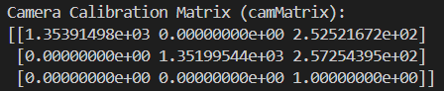 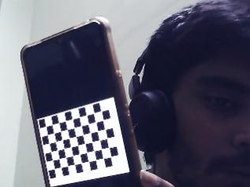

* **ArUco Marker Detection:**
  + Integrated ArUco markers for marker-based detection in the live camera feed.
  + Utilized a dictionary of ArUco markers with various configurations.
  + Developed a function to display detected ArUco markers on the camera feed.
  + Implemented logic to identify and track the positions of ArUco markers in real-time.

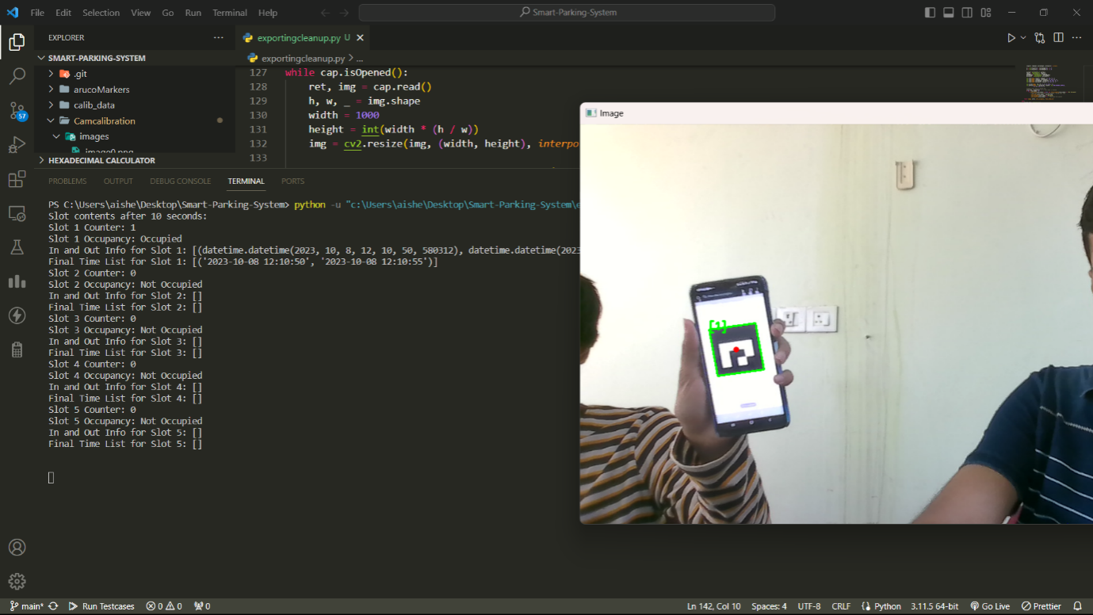

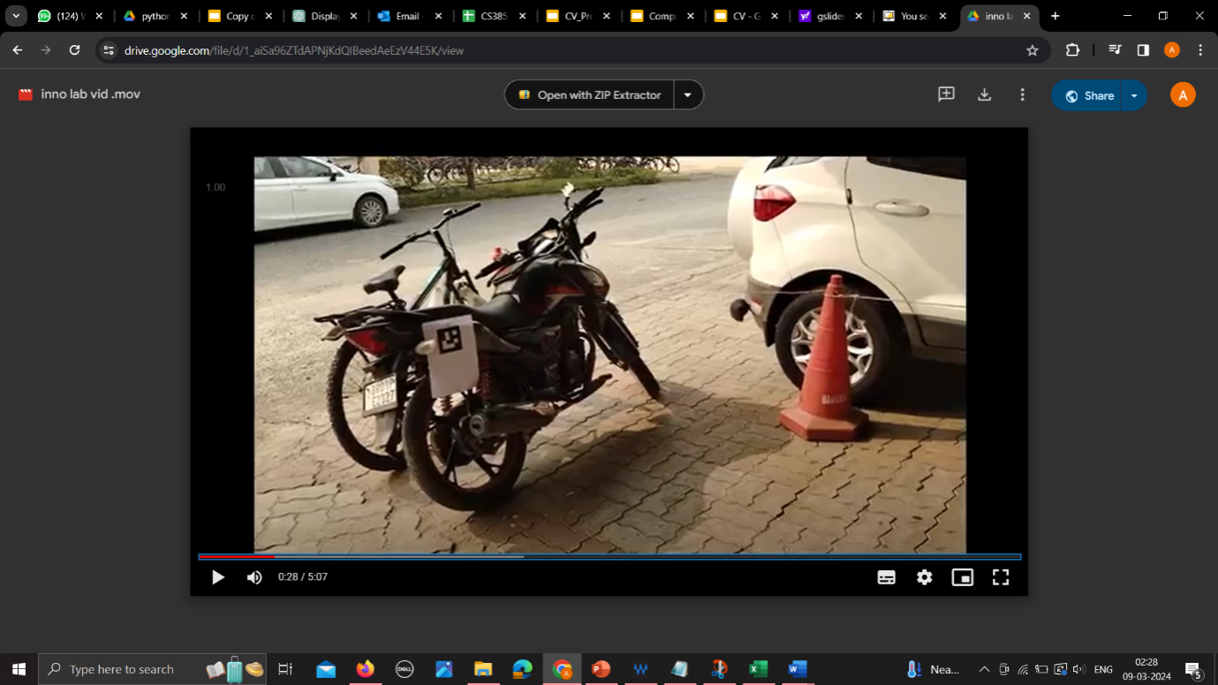

* **Slot Monitoring System:**
  + Established a slot monitoring system using ArUco markers to determine slot occupancy.
  + Recorded entry and exit times for each slot based on the presence of ArUco markers.
  + Implemented slot counters to keep track of the number of times each slot was occupied.

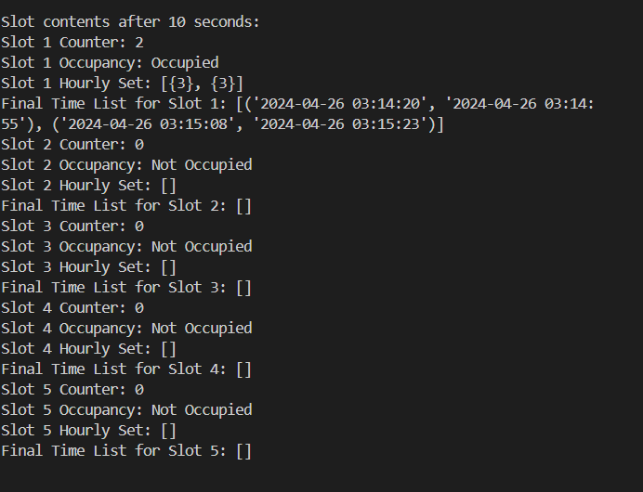

* **Data Export:**
  + Periodically printed and exported slot data, including occupancy status, counters, and hourly slot sets, to a CSV file.
  + Displayed the detected ArUco markers, slot occupancy, and relevant information on the live camera feed.

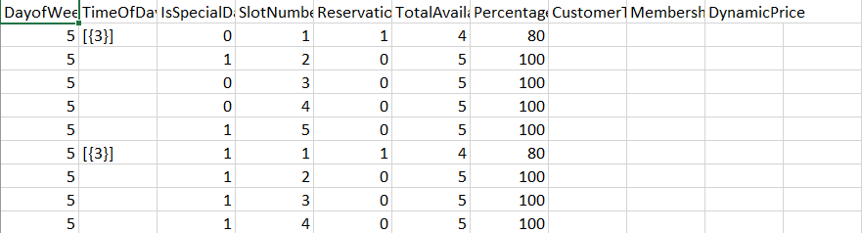

**Machine Learning Model:**

* **Dynamic Pricing:**
  + Regression-based machine learning algorithm.
  + It predicts the price of the parking slot based on the features 'DayOfWeek', 'TimeOfDay', 'IsSpecialDay', 'SlotNumber', 'PreviousReservations', 'TotalAvailableSpots', 'PercentageAvailableSpots', 'CustomerType', 'MembershipStatus'.
  + The dataset over which this model is trained is self-improving and with each new reservation it gets added to the dataset along with its predicted price, so that the next time it is used, it will predict a more accurate price.

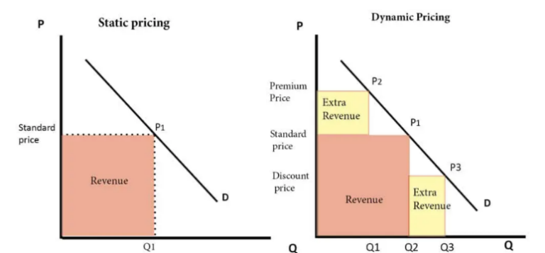

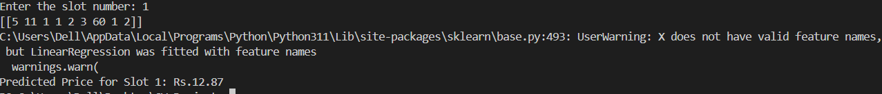

**Vehicle Detection and License Plate Recognition using YOLO and EasyOCR**

**Vehicle Detection with YOLO:**

* YOLO is a real-time object detection algorithm that divides images into a grid and predicts bounding boxes and class probabilities for objects within each grid cell.
* The YOLO model is trained using labeled datasets, allowing it to accurately detect vehicles in various environments.

We use two instances of the YOLO model:

a) One instance detects vehicles based on the Roboflow dataset, which contains diverse vehicle images for robust training.

b) Another instance is trained to detect license plates using a custom dataset specifically curated for license plate recognition tasks.

**License Plate Detection with EasyOCR:**

* EasyOCR is an OCR library that provides an interface for optical character recognition.
* Detected license plates are cropped from the original image and processed by the EasyOCR reader to extract alphanumeric characters.
* EasyOCR's robust recognition capabilities ensure accurate extraction of characters even in challenging lighting and environmental conditions.

**Implementation Details:**

* The YOLO model is trained using a combination of localization loss, confidence loss, and classification loss to optimize object detection performance.
* The training process involves iterating over labeled datasets, adjusting model parameters to minimize the defined loss functions.
* We evaluate the performance of the YOLO model using metrics such as precision, recall, F1 score, and mean average precision (mAP) to assess its effectiveness in detecting vehicles and license plates accurately.
* EasyOCR's performance is assessed based on its ability to correctly recognize alphanumeric characters from cropped license plate images.

**Metrics:**

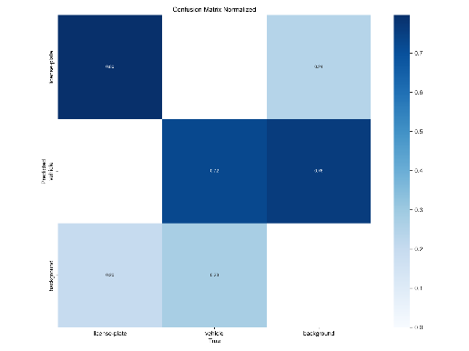 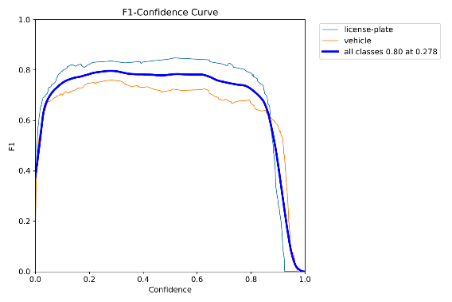

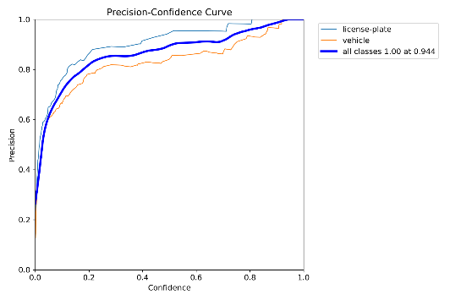 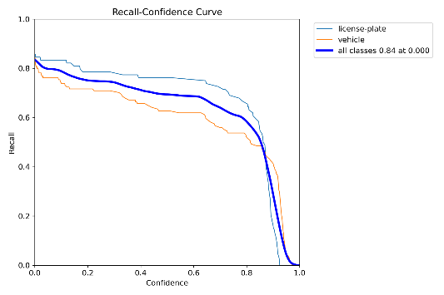

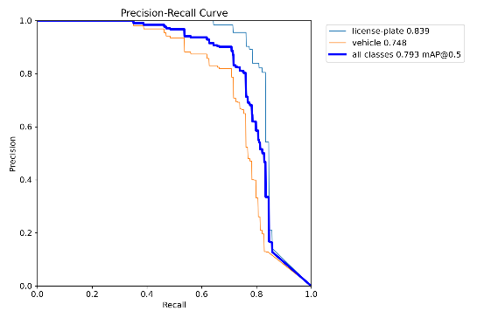

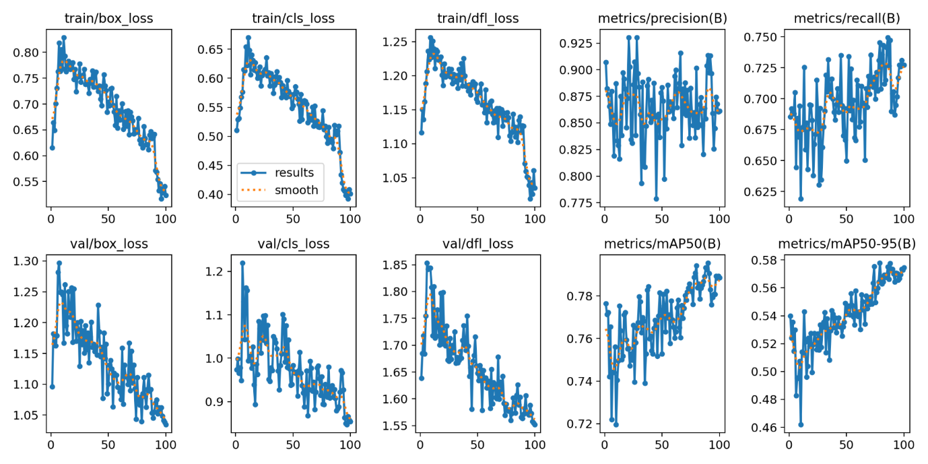

**Results**:

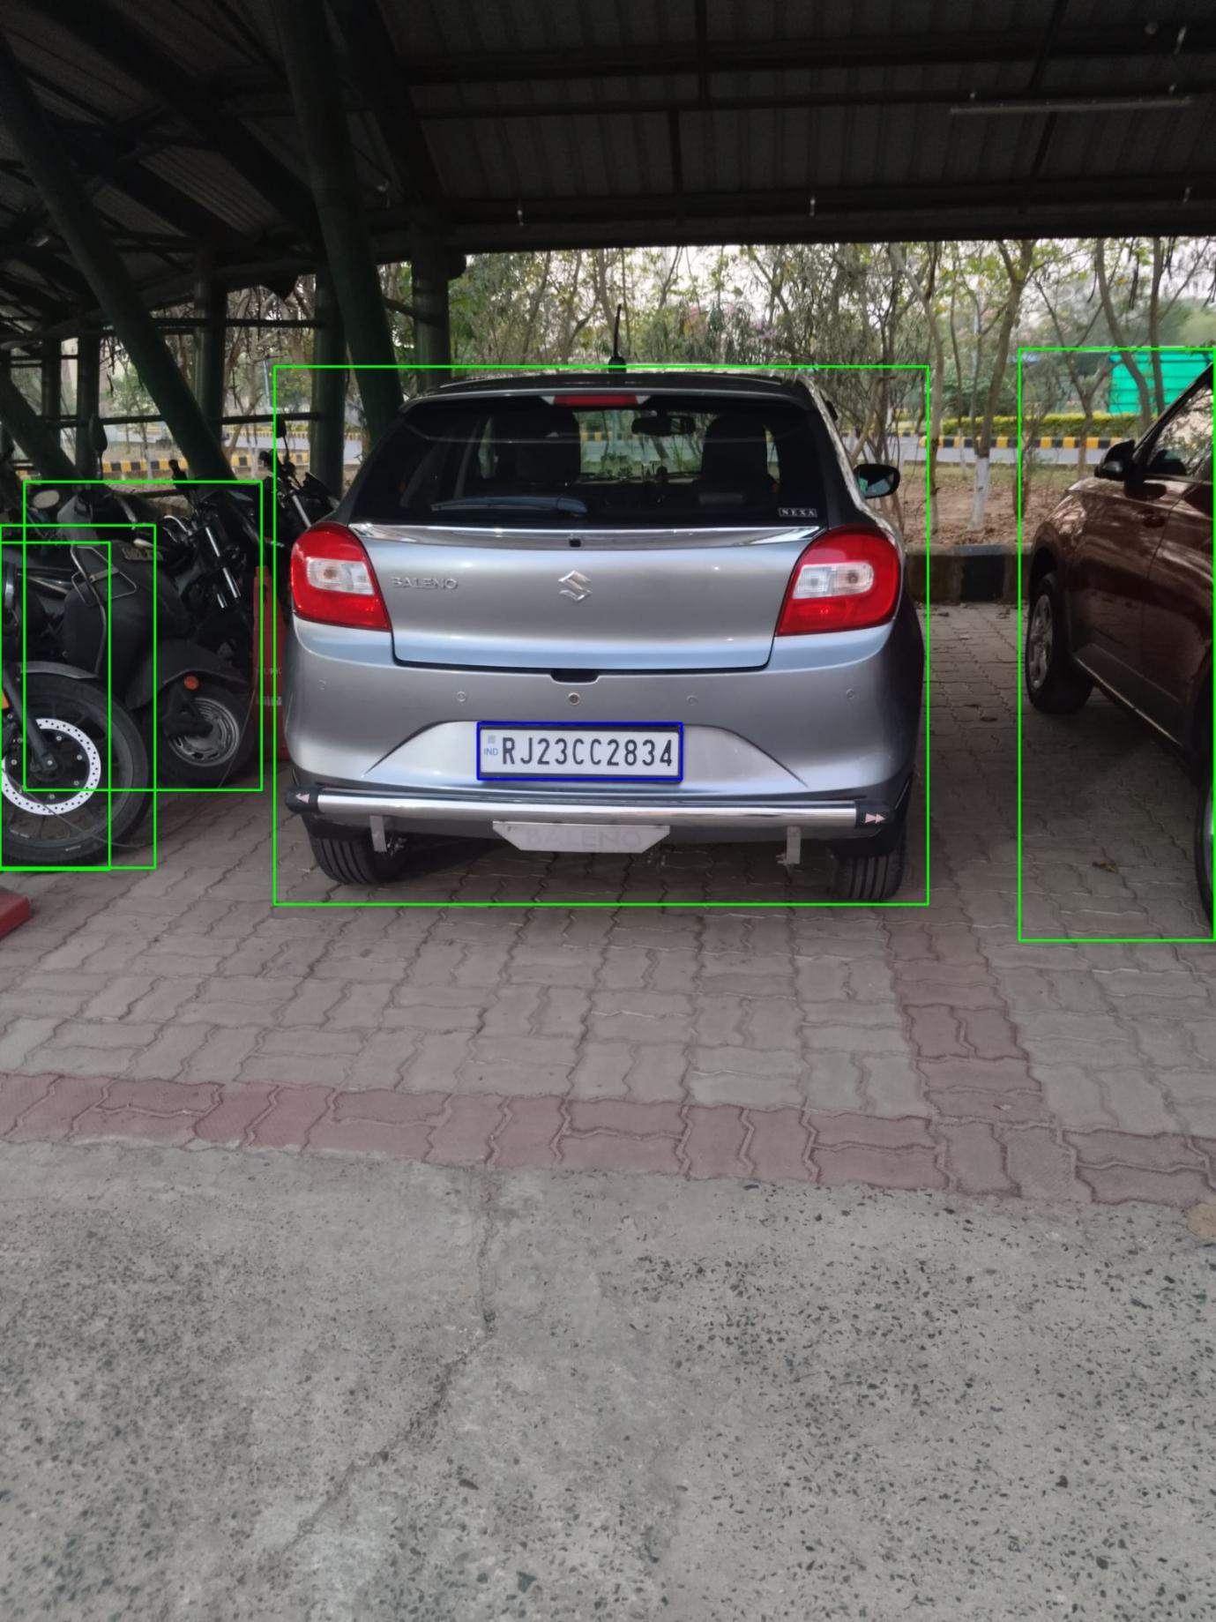

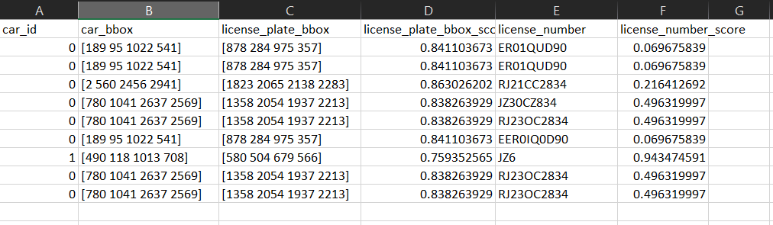

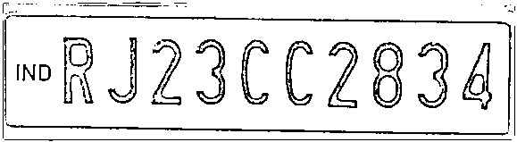

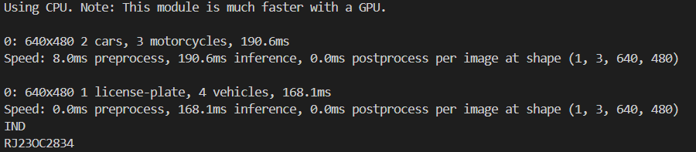

**Conclusion**

The integration of YOLO for vehicle detection and EasyOCR for license plate recognition presents a comprehensive solution for intelligent transportation systems. By leveraging state-of-the-art algorithms and advanced computer vision techniques, we achieve accurate and real-time detection of vehicles and extraction of license plate information. The robustness of our solution is evident in its ability to handle diverse environmental conditions and challenging scenarios, making it suitable for applications such as traffic management, parking enforcement, and security surveillance. The use of sophisticated loss functions, metrics, and evaluation techniques ensures the reliability and effectiveness of our approach. Moving forward, the continued advancement of technology in the field of computer vision will further enhance the capabilities of our system, contributing to safer, more efficient, and smarter transportation networks.